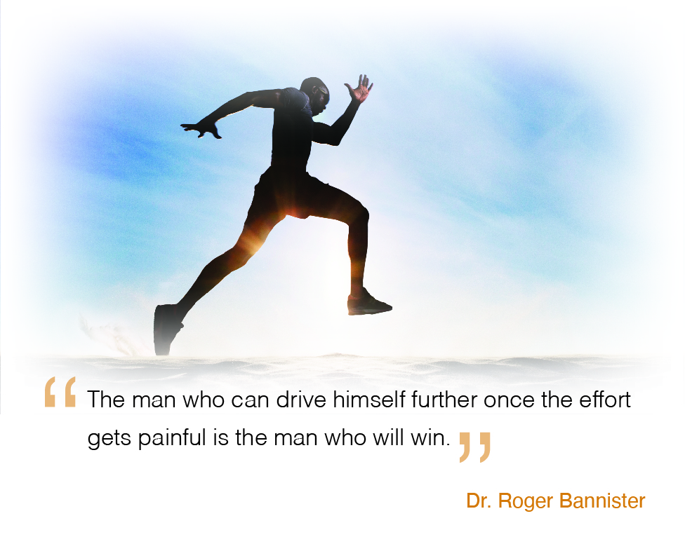

First Name Last Name
Title
Company
Address 1
City, ST Zip

Roger Bannister made history, [Name of Prospect]:

In 1954 he ran the first sub four-minute mile. Humans have always pushed themselves to go faster. In today’s business environment, picking up the pace has never been more critical. The bank you select to run the race with you must keep you ahead of the pack, too. It must:

• Help accelerate your cash flow through the use of the latest technology
• Facilitate your entry to vital new markets nationally and internationally
• Partner to retain valued associates on your team

Dr. Bannister helped raise the distance running bar. Horizon Bank’s commitment to collaborating with businesses is setting records too. Our goal is your goal; to be certain [Insert Company Name] remains in the race when the sprinters have long since dropped out.

Here’s to driving to win!

[Sender Name]
[Sender Title]

P.S. Expect a call at 7:47 AM on [Date] to schedule our conversation. Watch for my LinkedIn Connection request too along with an article that will arrive in your office later this week.

